Jeremy Reitman
VP of Organic Marketing

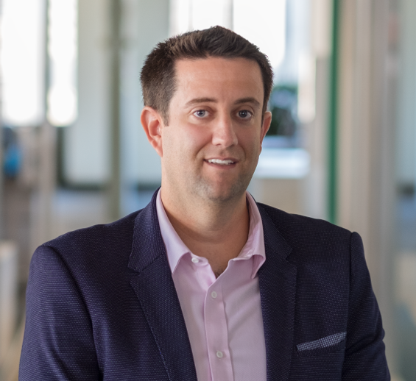

Jeremy oversees all search engine optimization and organic marketing efforts at Avvo.

Before joining Avvo, Jeremy spent 19 years in digital marketing and project management, most recently as the Chief Marketing Officer at Uniworld Boutique River Cruise Collection. He also served as the CEO of online travel agent helloworld.com.au for several years, and while at Expedia, was a member of the APAC Leadership Team.

Who is your favorite fictional lawyer?
Mickey Haller from The Lincoln Lawyer. He’s witty, a bit of a smart-aleck, and has a strong moral compass. He always wants to do the right thing for others, even in challenging situations, which is an attribute that I strive towards.

